26-04-2020

# Data structure in java:

* Enumeration
* BitSet
* Vector
* Stack
* Dictionary
* Hashtable
* Properties

# Enumeration:

It defines the methods by which I can enumerate the elements in a collection of objects.

Boolean hasMoreElements(): it returns true if there still more element to extract.

Object nextElement(): it returns the next object in the enumeration.

[Live Demo](http://tpcg.io/os1Caq)

import java.util.Vector;

import java.util.Enumeration;

public class EnumerationTester {

public static void main(String args[]) {

Enumeration days;

Vector dayNames = new Vector();

dayNames.add("Sunday");

dayNames.add("Monday");

dayNames.add("Tuesday");

dayNames.add("Wednesday");

dayNames.add("Thursday");

dayNames.add("Friday");

dayNames.add("Saturday");

days = dayNames.elements();

while (days.hasMoreElements()) {

System.out.println(days.nextElement());

}

}

}

#### Output

Sunday

Monday

Tuesday

Wednesday

Thursday

Friday

Saturday

# Vector:

**Enumeration elements()**

Returns an enumeration of the components of this vector.

**void ensureCapacity(int minCapacity)**

Increases the capacity of this vector, if necessary, to ensure that it can hold at least the number of components specified by the minimum capacity argument.

**void ensureCapacity(int minCapacity)**

Increases the capacity of this vector, if necessary, to ensure that it can hold at least the number of components specified by the minimum capacity argument.

# Stack:

**Object peek( )**

Returns the element on the top of the stack, but does not remove it.

# Hashtable:

**Enumeration keys( )**

Returns an enumeration of the keys contained in the hash table.

[Live Demo](http://tpcg.io/5eD0B4)

import java.util.*;

public class HashTableDemo {

public static void main(String args[]) {

// Create a hash map

Hashtable balance = new Hashtable();

Enumeration names;

String str;

double bal;

balance.put("Zara", new Double(3434.34));

balance.put("Mahnaz", new Double(123.22));

balance.put("Ayan", new Double(1378.00));

balance.put("Daisy", new Double(99.22));

balance.put("Qadir", new Double(-19.08));

// Show all balances in hash table.

names = balance.keys();

while(names.hasMoreElements()) {

str = (String) names.nextElement();

System.out.println(str + ": " + balance.get(str));

}

System.out.println();

// Deposit 1,000 into Zara's account

bal = ((Double)balance.get("Zara")).doubleValue();

balance.put("Zara", new Double(bal + 1000));

System.out.println("Zara's new balance: " + balance.get("Zara"));

}

}

#### Output

Qadir: -19.08

Zara: 3434.34

Mahnaz: 123.22

Daisy: 99<https://www.guru99.com/images/1/2.png>.22

Ayan: 1378.0

<https://www.guru99.com/images/1/2.png>

Zara's new balance: 4434.34

# JVM:

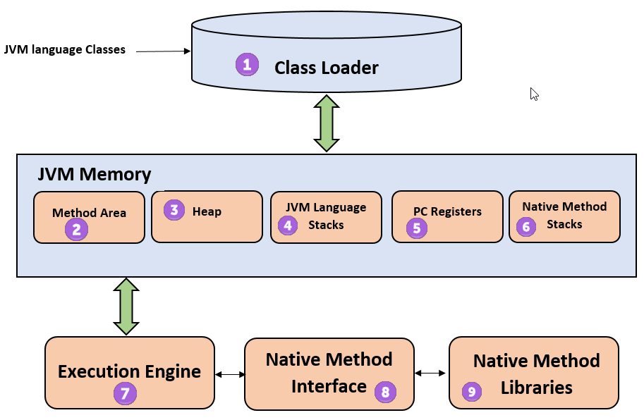

# ArrayList:

ArrayList is a data structure that can be stretched to accommodate additional elements within itself and shrink back to a smaller size when elements are removed. It is a very important data structure useful in handling the dynamic behavior of elements.

# HashMap:

A HashMap basically designates **unique keys** to corresponding **values** that can be retrieved.

HashMap stores only **object** **references**. That is why, it is impossible to use **primitive data types** like double or int. Use wrapper class (like Integer or Double) instead.

If **no element** exists in the Map, it will throw a ‘**NoSuchElementException’**.

import java.util.HashMap;

import java.util.Map;

public class Sample_TestMaps{

public static void main(String[] args){

Map<String, String> objMap = new HashMap<String, String>();

objMap.put("Name", "Suzuki");

objMap.put("Power", "220");

objMap.put("Type", "2-wheeler");

objMap.put("Price", "85000");

System.out.println("Elements of the Map:");

System.out.println(objMap);

}

}

Output:

Elements of the Map:

{Type=2-wheeler, Price=85000, Power=220, Name=Suzuki}

To remove a key value.

map.remove(5);

# Garbage collection:

An object once created uses some memory and the memory remains allocated till there are references for the use of the object. When there are no references to an object, it is assumed to be no longer needed, and the memory, occupied by the object can be reclaimed

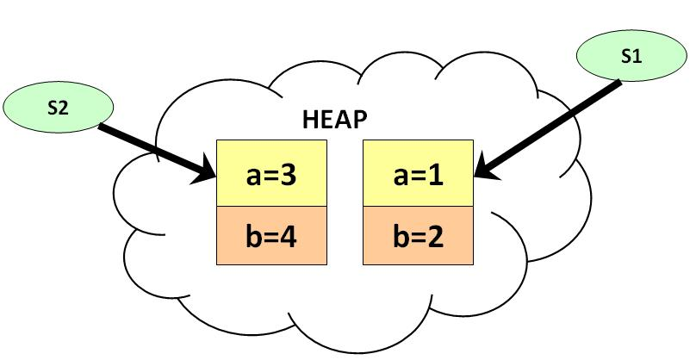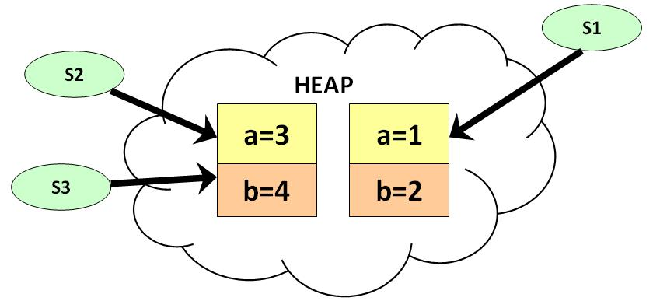

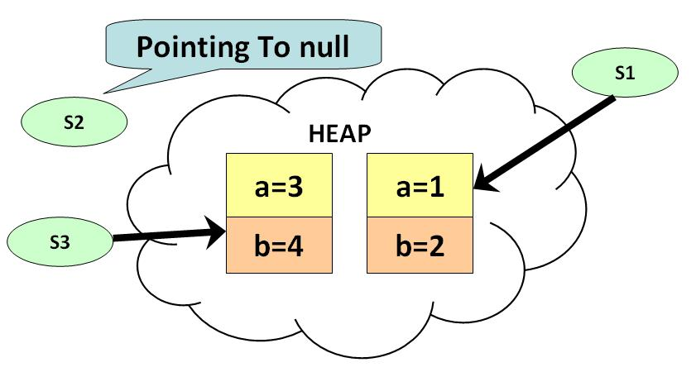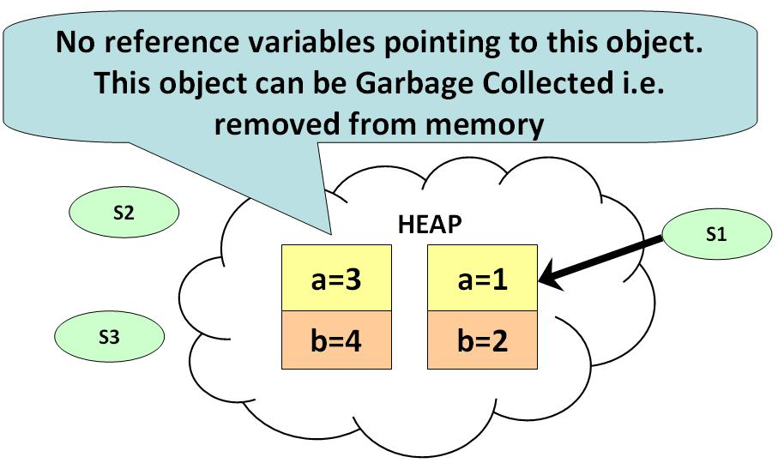

# Static Method:

Static method in Java is a method which belongs to the class and not to the object. A static method can access only static data. It is a method which belongs to the class and not to the object(instance). A static method can access only static data. It cannot access non-static data (instance variables).

* A static method can call only other static methods and can not call a non-static method from it.
* A static method can be accessed directly by the class name and doesn’t need any object
* A static method cannot refer to "this" or "super" keywords in anyway

# Deep copy and Shallow copy:

Link: <https://www.youtube.com/watch?v=QaCYMgyprtc>

Shallow copies duplicate as little as possible. A shallow copy of a collection is a copy of the collection structure, not the elements. With a shallow copy, two collections now share the individual elements.

Deep copies duplicate everything. A deep copy of a collection is two collections with all of the elements in the original collection duplicated.

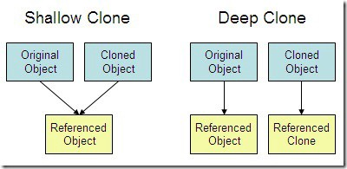

# Private Constructor:

In Java, private constructors are used in singleton class. In private constructor, only one object can be created and the object is created within the class and also all the methods are static. An object can not be created if a private constructor is present inside a constructor. A class which have a private constructor and all the methods are static then it is class Utility class.

final class abc

{

private abc()

{}

public static void add(int a, int b)

{

int z = a+b;

System.out.println("Addition: "+z);

}

public static void sub(int x, int y)

{

int z = x-y;

System.out.println("Subtraction: "+z);

}

}

class PrivateConDemo

{

public static void main(String as[])

{

abc.add(4, 5);

abc.sub(5, 3);

}

}

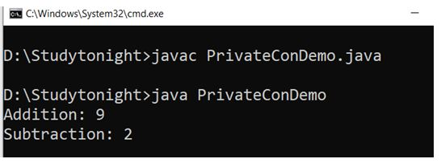

# Singleton Class:

In Java, a Singleton class is used when we want to create only one object at a time. To create a singleton class we have to create a private constructor and methods of the class should be static. The concept of Lazy initialization is used for creating a static method. The main difference between a normal class and a singleton class is that in normal class we use constructor and in singleton class, we use **getInstance()** method. The **getInstance()** method creates an object with the name of the class.

class Demo1{

private static Demo1 a = null;

public String s;

private Demo1()

{

s = "Hello Welcome to studytonight.com. You are Reading about Singleton class";

}

public static Demo1 getInstance()

{

if (a== null)

a = new Demo1();

return a;

}

}

class SingletonDemo1

{

public static void main(String args[])

{

Demo1 p = Demo1.getInstance();

Demo1 q = Demo1.getInstance();

Demo1 r = Demo1.getInstance();

p.s = (p.s).toUpperCase();

System.out.println("String from p is " + p.s);

System.out.println("String from q is " + q.s);

System.out.println("String from r is " + r.s);

System.out.println("\n");

r.s = (r.s).toLowerCase();

System.out.println("String from p is " + p.s);

System.out.println("String from q is " + q.s);

System.out.println("String from r is " + r.s);

}

}

Output:

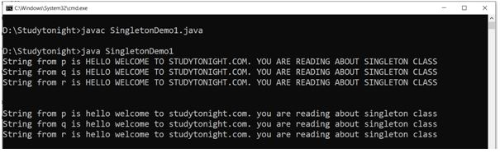

It **is** used where only a single instance of a **class is** required to control the action throughout the execution. A **singleton class** shouldn't have multiple instances in any case and at any cost. **Singleton classes are** used for logging, driver objects, caching and thread pool, database connections.

27/04/2020

# Constrained Layout :

* Convert from other types of layouts to ConstraintLayout.
* Dynamically position UI elements onscreen in relation to other elements.
* Animate your views.

1.We can convert Linear Layout to Constraint Layout 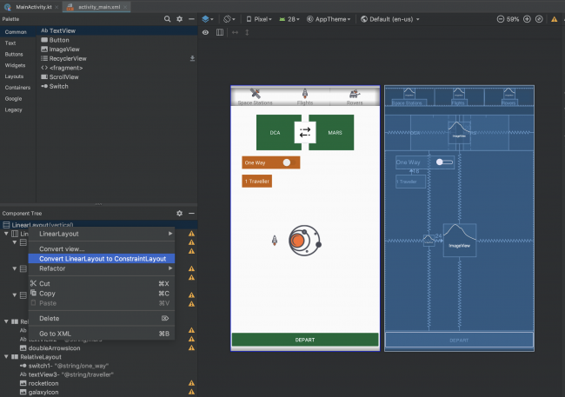

2. Make sure the auto connect is turned off:

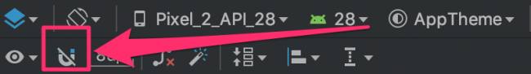

3. During the conversion process, Android Studio performs a number of steps. The last one may have been Infer Constraints, whose results might not quite be what you wanted. ;] If that’s the case, simply go to the Edit menu and choose Undo Infer Constraints or just click ctrl + z

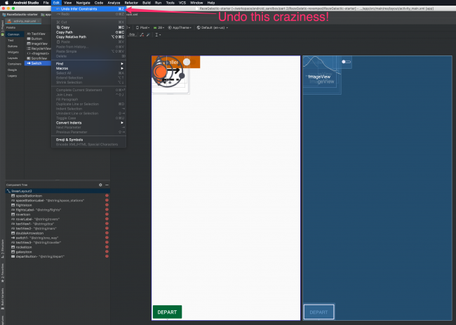

#### 4.Chains:

A chain occurs whenever there is bi-directional constraints. Nothing will specially change in the xml . if there is mutual constraints then we can make a chain.

Shift + select two or more component and with right-click select center > horizontally.

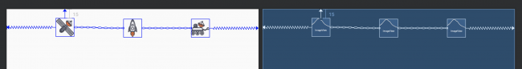

There are three chain modes:

1. Packed

2. Spread

3. Spread inside

5.Aligning Views

6. Guidelines:

We can add Guidelines from toolbar either horizontal guideline or vertical guideline. The other element can be constrained with respect these guidelines and it helps to create animation using keyframes.

7. Circular Position Constraints:

UI elements can be constrain relative to each other using distance and an angle. This allows us to position them on a circle.

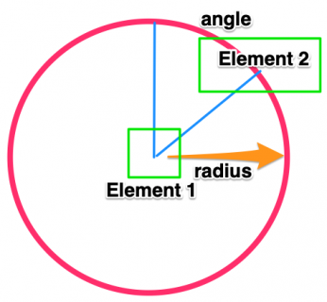

<ImageView

android:id="@+id/rocketIcon"

android:layout_width="30dp"

android:layout_height="30dp"

android:src="@drawable/rocket_icon"

app:layout_constraintCircle="@id/galaxyIcon"

app:layout_constraintCircleAngle="270"

app:layout_constraintCircleRadius="100dp" />

*** we can animate the constraint layout by copying similar but slightly changed xml file with a different name and it can be animated with toggling the layout with transition or with the constraintSet ( constraint attribute of an element) .

# SharedPreference:

Link: <https://codelabs.developers.google.com/codelabs/android-training-shared-preferences/index.html?index=..%2F..android-training#3>

read that data back in when the app is restarted

private SharedPreferences mPreferences; // member variable to hold a reference of a shared preference  
private String sharedPrefFile = "com.example.android.hellosharedprefs"; // member variable to hold the name of the sharedpref file

The preference file can have different name but it is convenient to keep it same as the package name.

Inside of onCreate() method

mPreferences = getSharedPreferences(sharedPrefFile, *MODE_PRIVATE*); // initialize the shared pref  
//getSharedPreferences() method opens the pref file named 'sharedPrefFile' and with mode 'MODE_PRIVATE'

***MODE_PRIVATE is highly recommended.

Now let’s save preferences in onPause()

@Override  
protected void onPause() {  
 super.onPause();  
  
 SharedPreferences.Editor preferencesEditor = mPreferences.edit();  
 //SharedPreferences.Editor is needed to edit the shared pref file  
 //this class includes multiple "put" methods for different data types  
  
 preferencesEditor.putInt(COUNT_KEY,mCount);// saving the count key-value pair  
 preferencesEditor.putInt(COLOR_KEY,mColor);// saving the color key-value pair  
  
 preferencesEditor.apply();  
 //this will save the preferences  
 //apply() method saves the preferences asynchronously  
 //commit() method saves the preferences asynchronously  
}

Restore preferences in onCreate()

// Restore the shared preference data  
mCount = mPreferences.getInt(COUNT_KEY,0);  
mColor = mPreferences.getInt(COLOR_KEY,mColor);  
//It don't need to get a shared preference editor for reading  
//getInt() take a key and a default value . it returns saved value if found any  
//otherwise it returns default value in this case,0 for count and mColor for color

Now reset the sharedpreference with a button:

SharedPreferences.Editor preferencesEditor = mPreferences.edit();  
//this will needed to edit the mPreferences reference  
preferencesEditor.clear();  
// simple idea is to clear the editor  
preferencesEditor.apply();  
//and apply it to save with empty preference

Summery:

* The [SharedPreferences](https://developer.android.com/reference/android/content/SharedPreferences.html) class allows an app to store small amounts of primitive data as key-value pairs.
* Shared preferences persist across different user sessions of the same app.
* To write to the shared preferences, get a [SharedPreferences.Editor](https://developer.android.com/reference/android/content/SharedPreferences.Editor) object.
* Use the various "put" methods in a SharedPreferences.Editor object, such as [putInt()](https://developer.android.com/reference/android/content/SharedPreferences.Editor#putInt(java.lang.String,%20int)) or [putString()](https://developer.android.com/reference/android/content/SharedPreferences.Editor#putString(java.lang.String,%20java.lang.String)), to put data into the shared preferences with a key and a value.
* Use the various "get" methods in a SharedPreferences object, such as [getInt()](https://developer.android.com/reference/android/content/SharedPreferences#getInt(java.lang.String,%20int)) or [getString()](https://developer.android.com/reference/android/content/SharedPreferences#getString(java.lang.String,%20java.lang.String)), to get data out of the shared preferences with a key.
* Use the [clear()](https://developer.android.com/reference/android/content/SharedPreferences.Editor#clear()) method in a SharedPreferences.Editor object to remove all the data stored in the preferences.
* Use the [apply()](https://developer.android.com/reference/android/content/SharedPreferences.Editor#apply()) method in a SharedPreferences.Editor object to save the changes to the preferences file.

# Store object in sharedreferences:

We can do this by converting the object into a json using (Gson library) and then store the json string in shared preference file. **Gson** is a Java library that can be used to convert Java Objects into their JSON representation

#### implementation 'com.google.code.gson:gson:2.8.5'

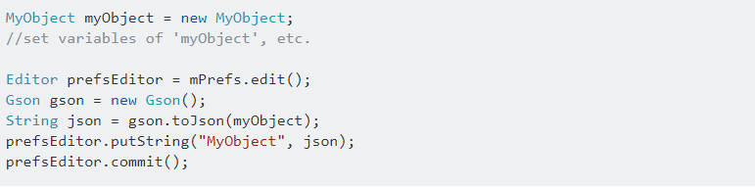

Then we can retrieve the json string of that object and again convert it into Object reference.

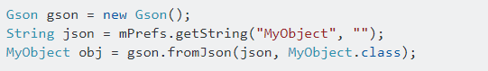

28-04-2020

# Multithreading basic:

Every java application has at least one thread – [main thread](https://www.journaldev.com/611/exception-in-thread-main-java).The benefits of java threads:

1. Java Threads are lightweight compared to processes, it takes less time and resource to create a thread.
2. Threads share their parent process data and code
3. Context switching between threads is usually less expensive than between processes.
4. Thread intercommunication is relatively easy than process communication.

Java provides two ways to create a thread programmatically.

1. Implementing the **java.lang.Runnable** interface.
2. Extending the **java.lang.Thread** class.

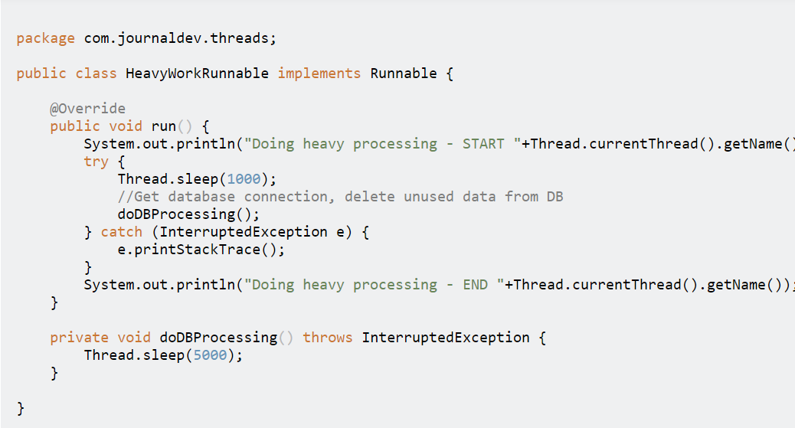

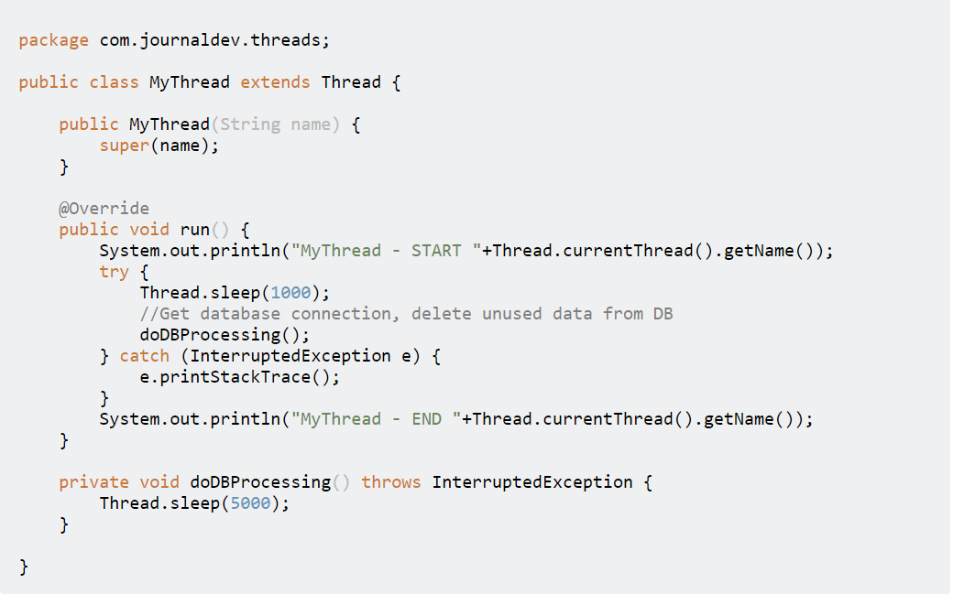

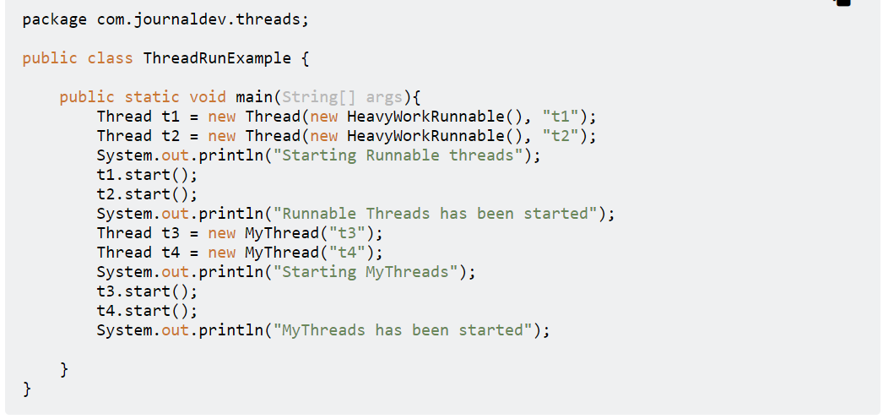

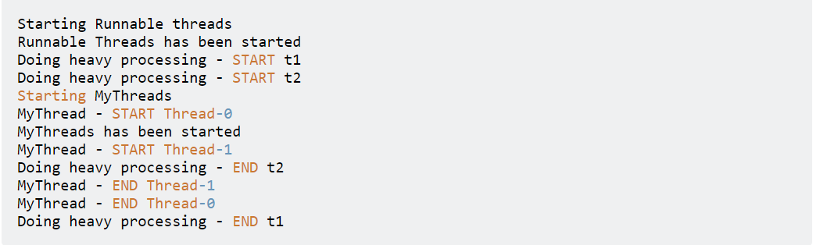

Once we start any thread, it’s execution depends on the OS implementation of time slicing and we can’t control their execution. However we can set threads priority but even then it doesn’t guarantee that higher priority thread will be executed first.

If your class provides more functionality rather than just running as Thread, you should implement Runnable interface to provide a way to run it as Thread. If your class only goal is to run as Thread, you can extend Thread class.

Implementing Runnable is preferred because java supports implementing multiple interfaces. If you extend Thread class, you can’t extend any other classes.

## Thread.sleep()

* method can be used to pause the execution of current thread for specified time in milliseconds.
* The actual time thread sleeps before waking up and start execution depends on system timers and schedulers. For a quiet system, the actual time for sleep is near to the specified sleep time but for a busy system it will be little bit more.
* It always pause the current thread execution.
* Any other thread can interrupt the current thread in sleep, in that case InterruptedException is thrown.

## Thread.join()

Using this method we can wait the execution of next thread until the previous thread is finished.

# Parcelable

Link: <https://medium.com/@royanimesh2211/implementing-the-parcelable-interface-in-android-b404819ca441>

Parcelable is an Android only interface which is used to serialize a class so its properties can be transferred from one activity to another. Parcelable is relatively fast as compared to the java serialization.

## writeToParcel Method:

In this method, you need to add all the properties to a parcel which you want to transfer. You use **write** methods to add each of the properties.

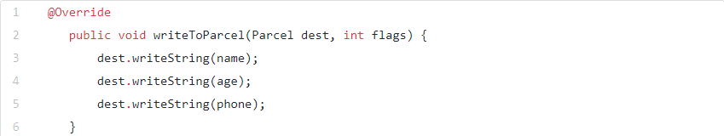

Constructor used to reading and saved values from the parcel:

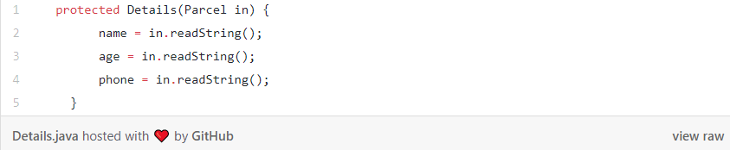

CREATOR used for unparcelling the parcel (creating the object). This method is to bind everything together

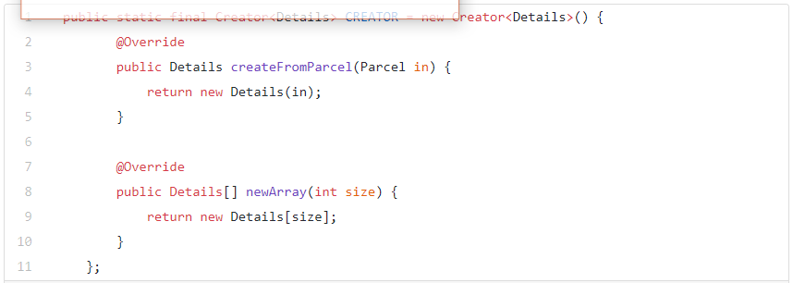

describeContents() method:

This method returns the hashcode of the object. This method does not do too much.

# Implicit intents

Link: <https://codelabs.developers.google.com/codelabs/android-training-activity-with-implicit-intent/index.html?index=..%2F..%2Fandroid-training&authuser=1#0>

***activity can declare one or more intent filters in the AndroidManifest.xml file to advertise that the activity can accept implicit intents, and to define the types of intents that the activity will accept.

To match your request with an app installed on the device, the Android system matches your implicit intent with an activity whose intent filters indicate that they can perform the action. If multiple apps match, the user is presented with an app chooser that lets them select which app they want to use to handle the intent.

App for this:

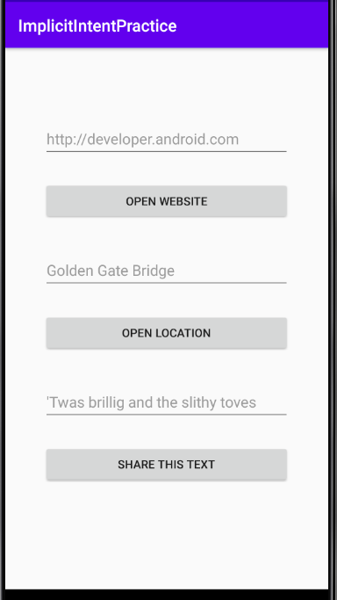 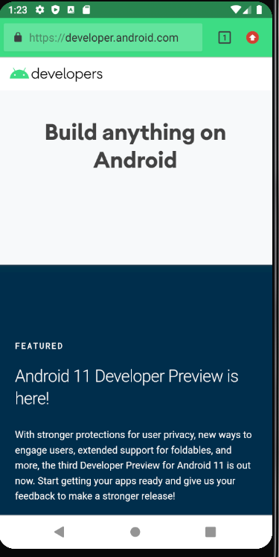 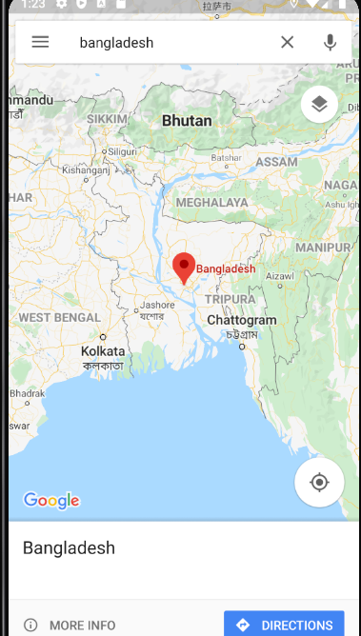

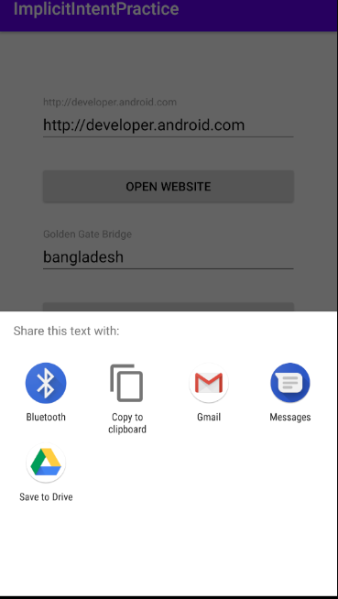 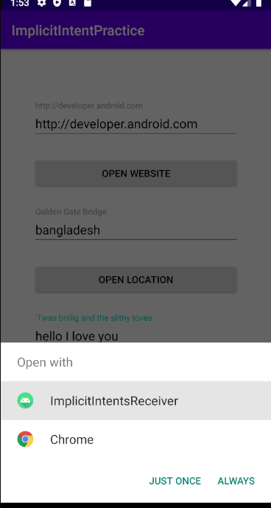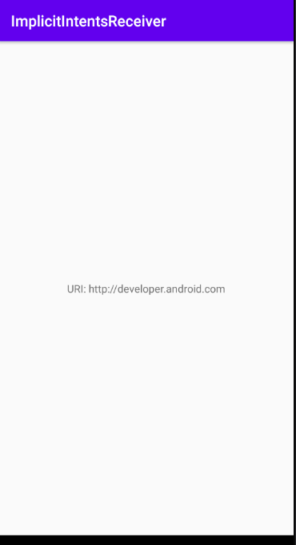

An Activity in your app can always be activated from inside or outside your app with an explicit Intent. To allow an Activity to receive an implicit Intent, you define an Intent filter in your app's AndroidManifest.xml file to indicate which types of implicit Intent your Activity is interested in handling.

When an app on the device sends an implicit Intent, the Android system matches the action and data of that Intent with any available Activity that includes the right Intent filters. When the Intent filters for an Activity match the Intent:

* If there is only one matching Activity, Android lets the Activity handle the Intent itself.
* If there are multiple matches, Android displays an app chooser to allow the user to pick which app they'd prefer to execute that action.

Then for the first app for using implicit intent we can do the code below:

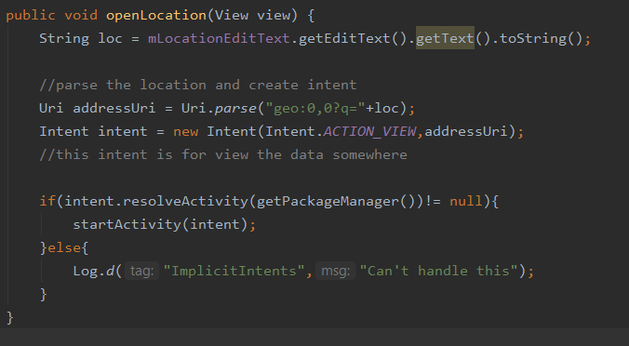

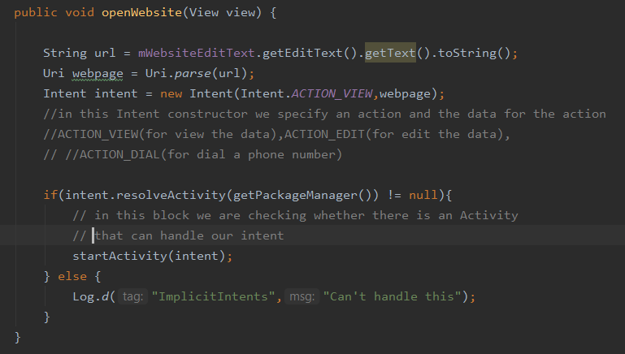

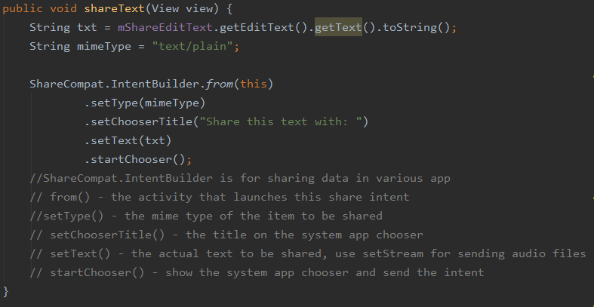

To response to implicit intents like this to app that we create we have to decleare intent filters with their properties in manifest.xml like the below:

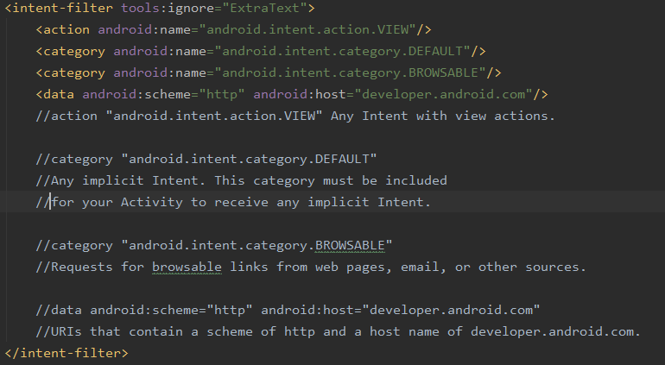

To handle the intent from any app and the data we will need to get the intent our mainactivity.java class like the below:

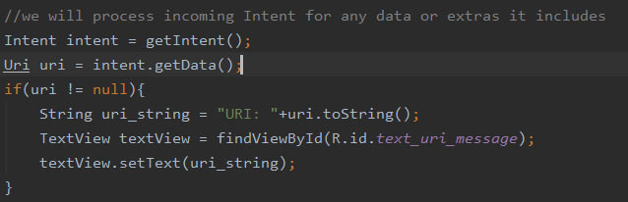

Some common Intents and intent filters:

Link: <https://developer.android.com/guide/components/intents-common>

29-04-2020

# Broadcast Receivers:

Broadcasts are messages that the Android system and Android apps send when events occur that might affect the functionality of other apps or app components. For example, the Android system sends a system broadcast when the device boots up, or when headphones are connected or disconnected. If the wired headset is unplugged, you might like your media app to pause the music.

In this practical, you create an app that responds to a change in the charging state of the device. To do this, your app receives and responds to a system broadcast, and it also sends and receives a custom broadcast

To create a new broadcast receiver, select the package name in the Android Project View and navigate to **File > New > Other > Broadcast Receiver**.

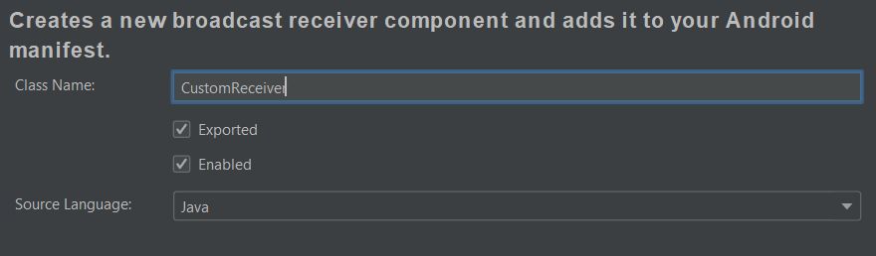

**Exported** allows your broadcast receiver to receive broadcasts from outside your app. **Enabled** allows the system to instantiate the receiver.

This is for static broadcast receiver. But does not support above API level 26 or android 8.0

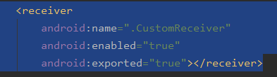

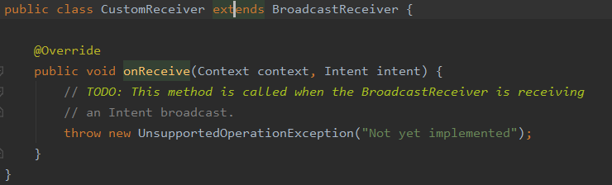

## **Register receiver for system broadcasts:**

A system broadcast is a message that the Android system sends when a system event occurs. Each system broadcast is wrapped in an Intent object:

-The intent's action field contains event details such as [android.intent.action.HEADSET_PLUG](https://developer.android.com/reference/android/content/Intent#ACTION_HEADSET_PLUG), which is sent when a wired headset is connected or disconnected.

A [BroadcastReceiver](https://developer.android.com/reference/android/content/BroadcastReceiver) is either a *static receiver* or a *dynamic receiver*, depending on how you register it:

* To register a receiver statically, use the <receiver> element in your AndroidManifest.xml file. Static receivers are also called *manifest-declared receivers*.
* To register a receiver dynamically, use the app context or activity context. The receiver receives broadcasts as long as the registering context is valid, meaning as long as the corresponding app or activity is running. Dynamic receivers are also called *context-registered receivers*.

***Starting from Android 8.0 (API level 26 and higher), you can't use static receivers to receive most Android system broadcasts, with some [exceptions](https://developer.android.com/guide/components/broadcast-exceptions). So for this task, you use dynamic receivers

# Implementation of dynamic broadcast receiver for system broad cast:

* Remove the <receiver> element from AndroidManifest.xml
* Create a CustomReceiver object and initialize it
* Create and IntentFilter object and initialize it in onCreate() method
* Add the actions to the intentFilter object
* Register and unregister the receiver
* Implement onReceive() in BroadcastReceiver



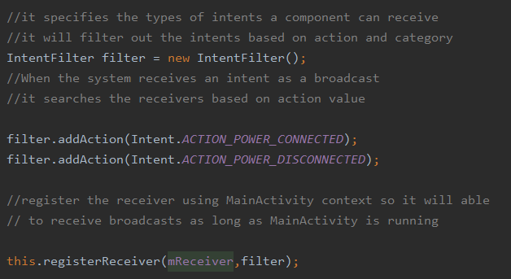

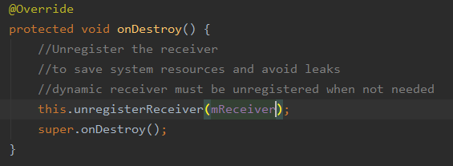

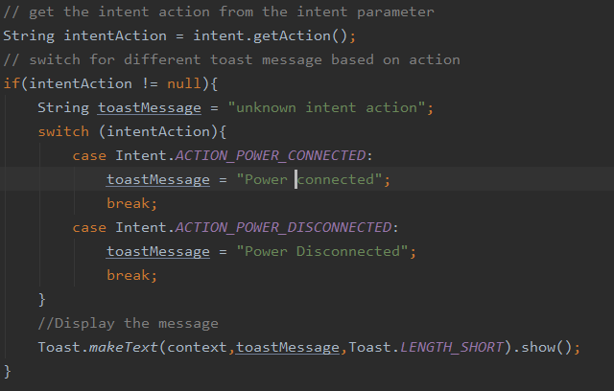

# Implement send and receive a custom broadcast:

Use a custom broadcast when you want your app to take an action without launching an activity, for example when you want to let other apps know that data has been downloaded to the device.

Android provides three ways for your app to send custom broadcasts:

* *Normal broadcasts* are asynchronous. Receivers of normal broadcasts run in an undefined order, often at the same time. To send a normal broadcast, create a broadcast intent and pass it to [sendBroadcast(Intent)](https://developer.android.com/reference/android/content/Context.html#sendBroadcast(android.content.Intent)).
* *Local broadcasts* are sent to receivers that are in the same app as the sender. To send a local broadcast, create a broadcast intent and pass it to [LocalBroadcastManager.sendBroadcast](https://developer.android.com/reference/android/support/v4/content/LocalBroadcastManager.html#sendBroadcast(android.content.Intent)).
* *Ordered broadcasts* are delivered to one receiver at a time. As each receiver executes, it can propagate a result to the next receiver, or it can cancel the broadcast so that the broadcast is not passed to other receivers. To send an ordered broadcast, create a broadcast intent and pass it to [sendOrderedBroadcast(Intent, String)](https://developer.android.com/reference/android/content/Context.html#sendOrderedBroadcast(android.content.Intent,%20java.lang.String)).

# Procedure:

* Define custom broadcast action string.prepending action name with app’s package name.to get package name use Buildconfig.APPLICATION_ID. So create a constant member variable in both MainActivity and CustomReceiver class.
* **Create ‘sendCustomBroadcast (View)' in 'MainActivity'.** And implement the method
  + **Create a new intent with custom broadcast action string**
  + **Send the broadcast using LocalBroadcastManager**
* Register and unregister the custom broadcast using LocalBroadcastManager
* Respond to the custom broadcast from customBroadcast.java class



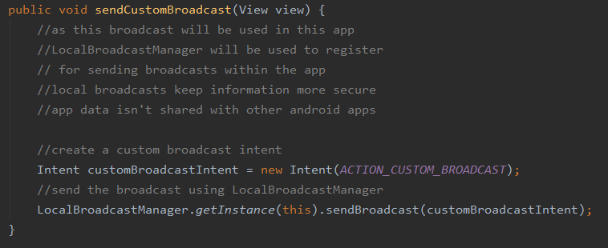

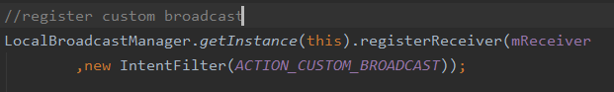



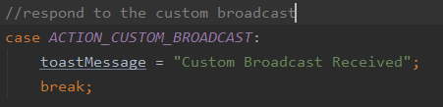

# Sending data using broadcast

* Use intent.putExtra() to put data in the intent
* In the receiver class get the extra from the intent and do operation on it

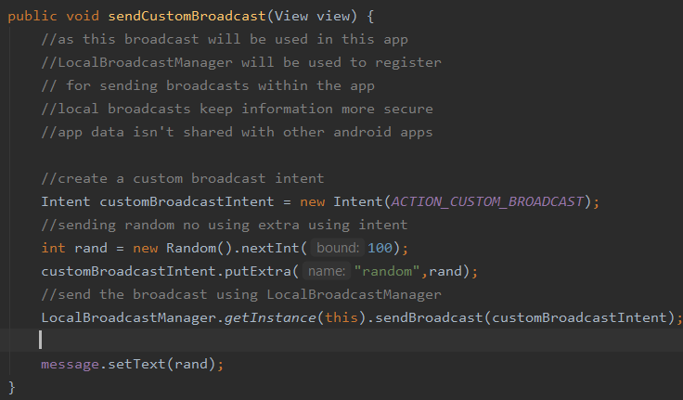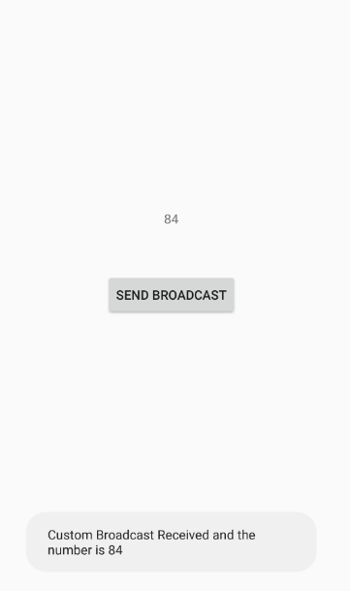

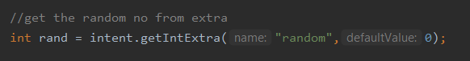

# Background Services:

Link: <https://developer.android.com/guide/components/services?authuser=1>

A [Service](https://developer.android.com/reference/android/app/Service?authuser=1) is an application component that can perform long-running operations in the background, and it doesn't provide a user interface. Another application component can start a service, and it continues to run in the background even if the user switches to another application. Additionally, a component can bind to a service to interact with it and even perform interprocess communication (IPC). For example, a service can handle network transactions, play music, perform file I/O, or interact with a content provider, all from the background.

These are the three different types of services:

* Foreground: A foreground service performs some operation that is noticeable to the user. For example, an audio app would use a foreground service to play an audio track. Foreground services must display a [Notification](https://developer.android.com/guide/topics/ui/notifiers/notifications?authuser=1). Foreground services continue running even when the user isn't interacting with the app.

*** using WorkManager is preferable to using foreground services directly.

* Background: A background service performs an operation that isn't directly noticed by the user. For example, if an app used a service to compact its storage, that would usually be a background service.
* Bound: A service is bound when an application component binds to it by calling [bindService()](https://developer.android.com/reference/android/content/Context?authuser=1#bindService(android.content.Intent,%20android.content.ServiceConnection,%20int)). A bound service offers a client-server interface that allows components to interact with the service, send requests, receive results, and even do so across processes with interprocess communication (IPC). A bound service runs only as long as another application component is bound to it. Multiple components can bind to the service at once, but when all of them unbind, the service is destroyed.

## Service vs thread:

A service is simply a component that can run in the background, even when the user is not interacting with your application, so you should create a service only if that is what you need.

If you must perform work outside of your main thread, but only while the user is interacting with your application, you should instead create a new thread.

## Procedure:

* Extend one of the following to create a started service:
  + **Service:** Base class for all services. Must have to create a new thread in which the service can complete all of it’s work. Otherwise it will use the main thread that will slow down application.
  + **IntentService:** This is a subclass of Service that uses a worker thread to handle all of the start requests, one at a time. This is the best option if service don’t handle multiple request simultaneously. It is preferred option
* override some callback methods that handle key aspects of the service lifecycle and provide a mechanism that allows the components to bind to the service
  + [OnStartCommand ()](https://developer.android.com/reference/android/app/Service?authuser=1#onStartCommand(android.content.Intent,%20int,%20int)) - The system invokes this method by calling [startService ()](https://developer.android.com/reference/android/content/Context?authuser=1#startService(android.content.Intent)) when another component (such as an activity) requests that the service be started. When this method executes, the service is started and can run in the background indefinitely.  to stop the service when its work is complete by calling [stopSelf()](https://developer.android.com/reference/android/app/Service?authuser=1#stopSelf()) or [stopService()](https://developer.android.com/reference/android/content/Context?authuser=1#stopService(android.content.Intent))
  + [onBind()](https://developer.android.com/reference/android/app/Service?authuser=1#onBind(android.content.Intent)) - The system invokes this method by calling [bindService()](https://developer.android.com/reference/android/content/Context?authuser=1#bindService(android.content.Intent,%20android.content.ServiceConnection,%20int)) when another component wants to bind with the service (such as to perform RPC). provide an interface to communicate with the service by returning an [IBinder](https://developer.android.com/reference/android/os/IBinder?authuser=1).
  + [onCreate()](https://developer.android.com/reference/android/app/Service?authuser=1#onCreate()) - The system invokes this method to perform one-time setup procedures when the service is initially created. If the service is already running, this method is not called.
  + [onDestroy()](https://developer.android.com/reference/android/app/Service?authuser=1#onDestroy()) - The system invokes this method when the service is no longer used and is being destroyed.
* Declare the service in the manifest
* To start the service,use an explicit intent with [startService()](https://developer.android.com/reference/android/content/Context?authuser=1#startService(android.content.Intent)).

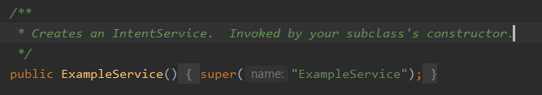

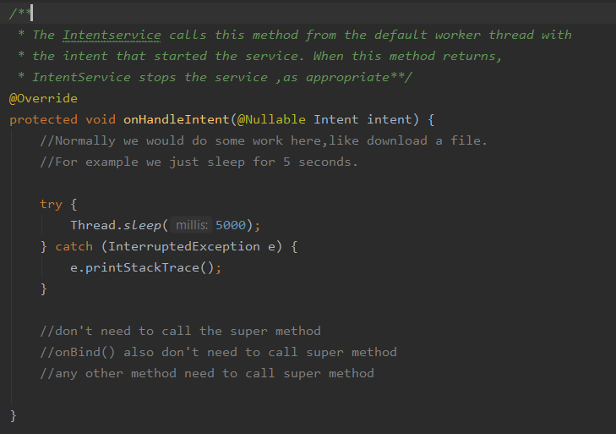

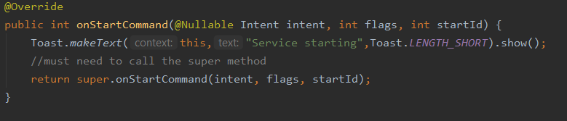

Using [IntentService](https://developer.android.com/reference/android/app/IntentService?authuser=1) makes your implementation of a started service very simple. If, however, you require your service to perform multi-threading (instead of processing start requests through a work queue), you can extend the [Service](https://developer.android.com/reference/android/app/Service?authuser=1) class to handle each intent.

Create a member object of Looper to loop through the thread messages. And a user defined ServiceHandler that extends Handler to handle multi-threading.

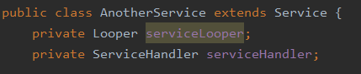

ServiceHandler class that extends Handler will receive the message for thread and will do some work in it’s handleMessage method. This is needed because Service class runs on the main thread that we don’t want . So we have to run the processes in different threads.

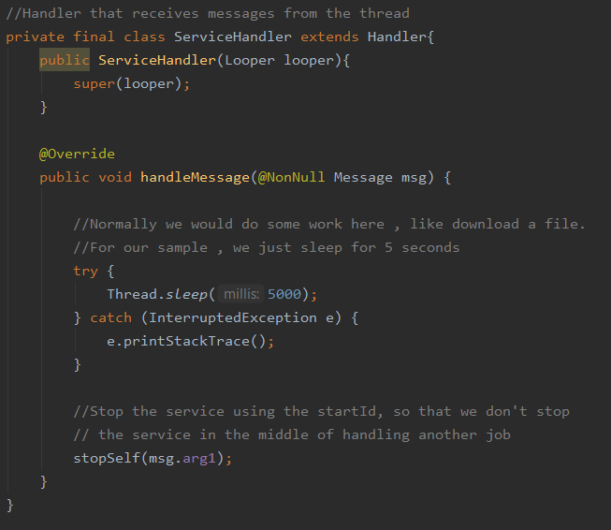

Create thread for the processing and get the thread’s Looper and send it to the ServiceHandler

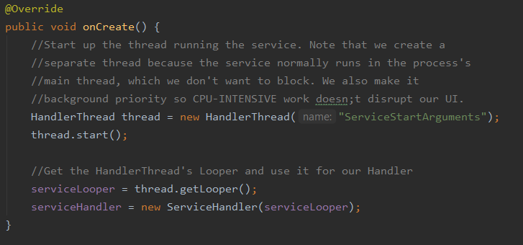

After sending the Looper to the Handler in onCreate() method, onStartCommand is called and here we create message to start a job with startId so we can know which job is we are killing after finish.

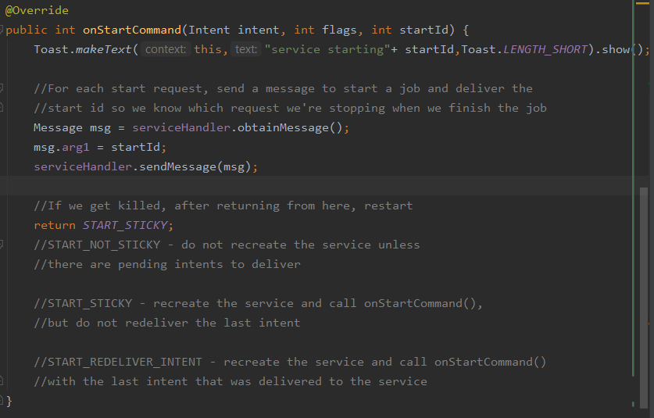

onDestroy() will called after stopSelf(msg.arg1) is executed on the handleMessage method of Handler class

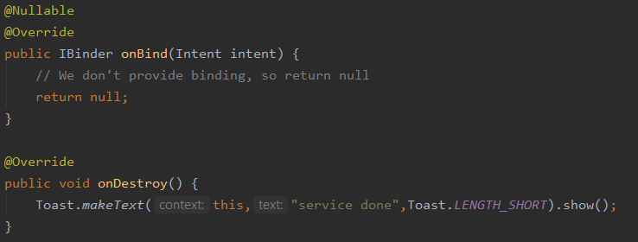

## When the service killed:

* Memory is low and to recover system resources for other focused activity
* If the service is bound to a focused activity it’s less likely to be killed
* If the service is decleared to run in the foreground it’s rarely killed
* After long running of the service it becomes highly susceptible to killing

Life Cycle of the service and bounds

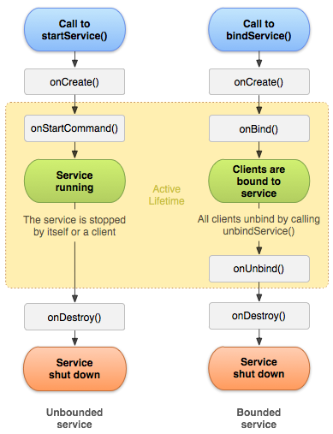

# Thread continues:

 set up and use multiple threads in an Android app, using a thread pool object. how to define code to run on a thread and how to communicate between one of these threads and the UI thread.

## Runnable thread:

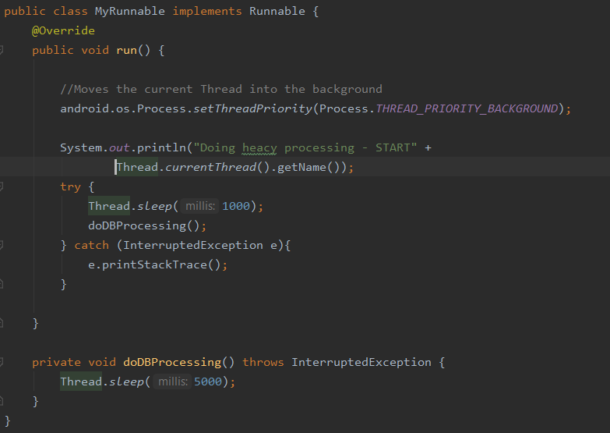

## Create a manager for multiple thread:

If you want to run a task repeatedly on different sets of data, but you only need one execution running at a time, an [IntentService](https://developer.android.com/reference/android/app/IntentService?authuser=1) suits your needs. To automatically run tasks as resources become available, or to allow multiple tasks to run at the same time (or both), you need to provide a managed collection of threads. To do this, use an instance of [ThreadPoolExecutor](https://developer.android.com/reference/java/util/concurrent/ThreadPoolExecutor?authuser=1), which runs a task from a queue when a thread in its pool becomes free. To run a task, all you have to do is add it to the queue.

 Enclose variables that can be accessed by more than one thread in a synchronized block. This approach will prevent one thread from reading the variable while another is writing to it. Typically, this situation arises with static variables, but it also occurs in any object that is only instantiated once.

30-04-2020 <-> 3-05-2020

# Assignment image picker – Done

Link : <https://github.com/AkashShahriar55/Training/tree/master/ImagePicker>

# Access media file from the shared storage:

The framework provides an optimized index into media collections, called the media store, that allows for retrieving and updating these media files more easily. Even after your app is uninstalled, these files remain on the user's device.

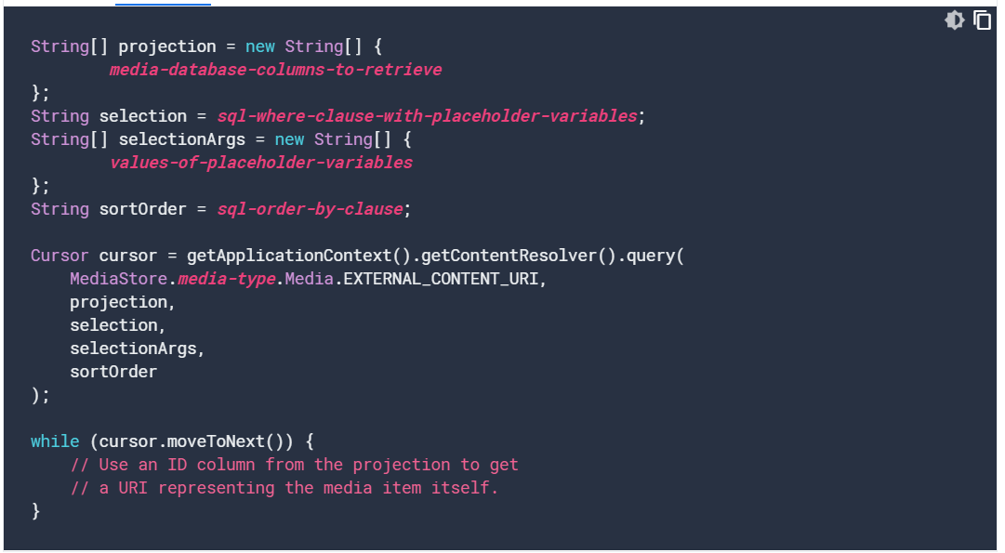

Process:

* Request necessary permissions
  + If scoped storage is enabled (above android 10) then don’t request storage related permission
  + Otherwise must request READ_EXTERNAL_STORAGE,WRITE_EXTERNAL_STORAGE permission
* Declare and instantiate an array of string called projection that will define the media database columns to retrieve - required
* Declare and instantiate an string for sql where clause with placeholder variable – ( optional – nullable)
* Declare and instantiate an string for sorting that will order by clause ( optional –nullable)
* To interact with the media store database a Cursor object is needed that can be got from context’s ContentResolver.
* Loop through the cursor using cursor.MoveToNext() and get the data using cursor.getColumnIndexOrThrow(column_name);

# Request App Permissions:

We must declare that our app needs a permission by listing the permission in the [app manifest](https://developer.android.com/guide/topics/manifest/manifest-intro) and then requesting that the user approve each permission at runtime (on Android 6.0 and higher).

Process:

* Put <uses-permission> element in the app manifest, as a child of the top level <manifest> element.

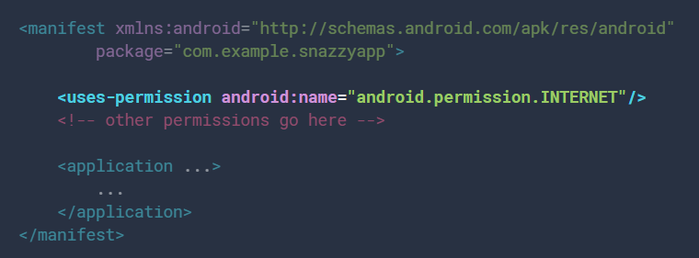

* For dangerous permission we must check the permission at runtime and have to ask the user for giving permission. To check runtime permission ContextCompat.checkSelfPermission() method is used. If has permission it will return PERMISSION_GRANTED otherwise PERMISSION_DENIED
* if it returns PERMISSION_DENIED then we have to request permission with requestPermissions() method. It will show up a standard android dialog
* sometimes it needed to explain user why the permission is needed ,in such cases we can use shouldShowRequestPermissionRationale() to check if user has denied the request earlier (return true) or not (return false)
* for accessing to sensitive user information related to call logs and sms messages , we must prompt user to set the app as default handler for a core system function.

Details:  [see the guide on permissions used only in default handlers](https://developer.android.com/guide/topics/permissions/default-handlers).

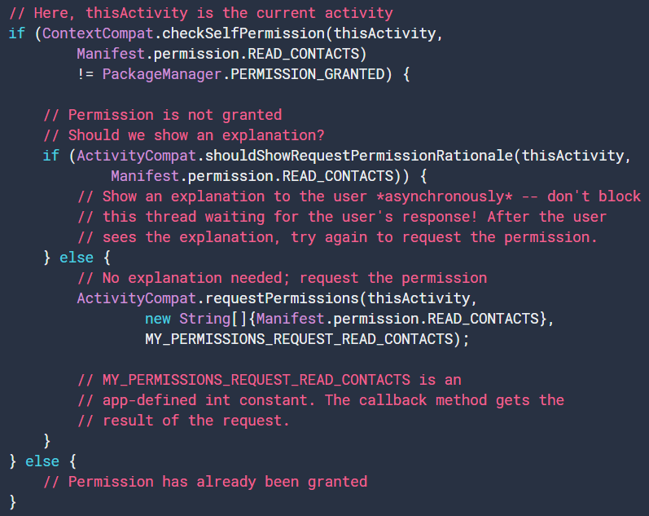

* when user responds to the app’s permission request the system invokes the app’s onRequestPermissionsResult() method. Using switch or if_else by checking the request code defined by developer (eg. MY_PERMISSION_REQUEST_READ_CONTACTS) we can check if the permission is granted or not .

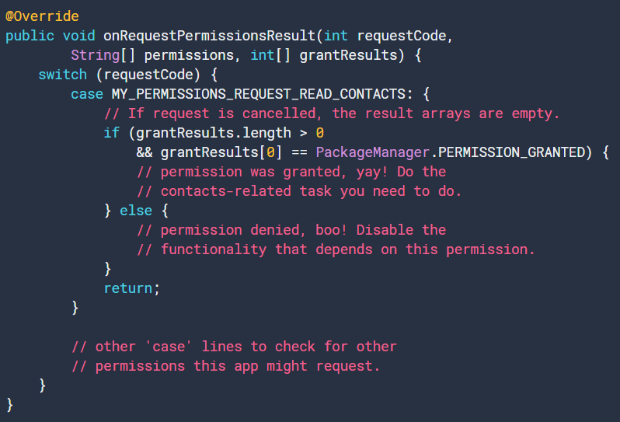

# Glide:

Link: <https://github.com/bumptech/glide>

Glide is a fast and efficient open source media management and image loading framework for Android that wraps media decoding, memory and disk caching, and resource pooling into a simple and easy to use interface.

Glide supports fetching, decoding, and displaying video stills, images, and animated GIFs. Glide includes a flexible API that allows developers to plug in to almost any network stack. By default Glide uses a custom HttpUrlConnection based stack, but also includes utility libraries plug in to Google's Volley project or Square's OkHttp library instead.

05-05-2020

# Android app fundamentals, Process and Threads

There are four different types of app components:

* Activity
* Services
* Broadcast receivers
* Content providers

## Activity – lifecycle:

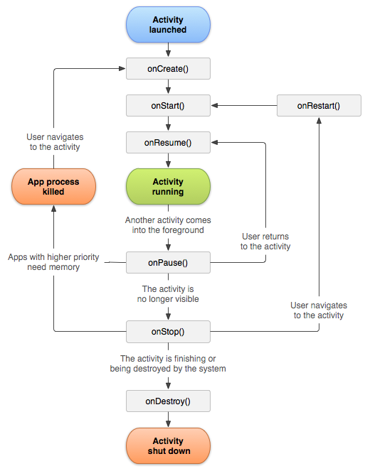

#### onCreate():

implement the logic that will happen only once in the whole life of the activity.

#### onStart():

implement the code that maintains the UI.

#### onResume():

it comes to the foreground. Implement onResume to initialize components that will release during onPause.eg. if the app is using camera then it should initialize it in onResume so in onPause method it releases the camera for use by other app.

**If you initialize something after the ON_START event, release or terminate it after the ON_STOP event. If you initialize after the ON_RESUME event, release after the ON_PAUSE event.

#### onPause():

activity may pause for these reasons :

* If some event interrupts the app
* If other app is in focus in ,multi-window mode ( above android 7.0)
* Semi-transparent activity ( like messenger) opens .

This can be used to release resources,handles to sensors,or any battery consuming operation.

This method should not be used to save application or user data, make network calls, or database transactions.

#### onStop():

it calls when a new app is opened or the app is closed; this method can be used to release resources.it also used to perform relatively CPU-intensive shutdown operations.

Eg. We can save draft of a message or note or email in this method.

#### onDestroy():

this method is called when the activity is finishing or the system is temporarily destroying the activity due to a configuration change.

**\*\*\*we should use ViewModel object to contain the relevant view data for the activity. If the activity recreated during config changes the ViewModel does not have to do anything since it will be preserved and given to the next Activity instance. If the activity does not recreated then the ViewModel have onCleared() method to clean up any data.**

The system kills the processes when it needs to free up RAM; the likelihood of the killing a given process

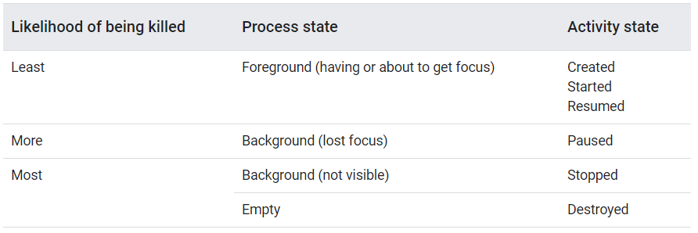

## Processes:

* In most case android apps runs in it’s own Linux process.
* Application don’t control the process’s lifetime.it determined by the system according to importance to the user.
* To determine which processes should be killed there is importance hierarchy:
  + **Foreground process**: a process is considered to be foreground if:
    - if user is interacting with It (onResume)
    - BroadcastReceiver is currently running (onReceive is executing)
    - Service that is currently executing code in one of it’s callbacks

These will only be killed as last resort if memory is so low to continue.

* + **Visible process:** process of user currently aware of ( like download or music player).a process will considered as visible process:
    - Visible to user on screen but not in the foreground .like messenger in foreground but other app is behind.
    - Service that is running as a foreground service ( Service.startForeground)
    - It is hosting a service that the system is using for a particular feature that the user is aware.

Less bounded that foreground processes

* + **Service process:**
    - Service that started using startService()
    - Though they are not visible but do important work
    - Long running services can be lose importance and demoted to cached list
  + **Cached process:**
    - Is not currently needed so system will kill freely
    - Regularly kill the oldest ones

A **process** has an ID, known as the PID (Process ID); a priority, how important is it; its own address space, that is its own chunk of memory; and some state information: running (or runnable), sleeping, stopped and zombie.

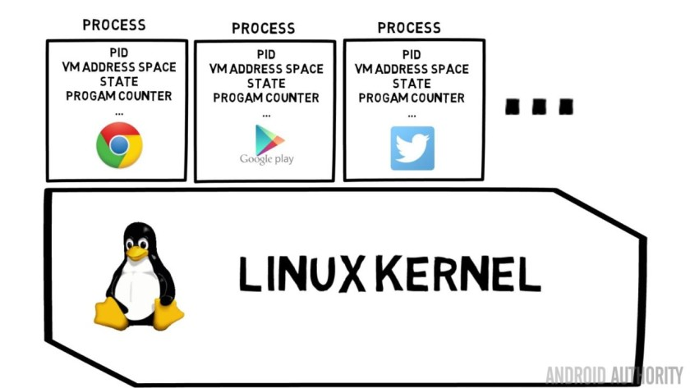

## Threads:

A **thread** is a line of execution inside the app’s executable code that occurs in parallel with other threads, which are also executing the same app code. By default every Linux program (and Android app) has one thread (Main thread/UI thread). The execution will start at beginning of the program and run till it finally exit.

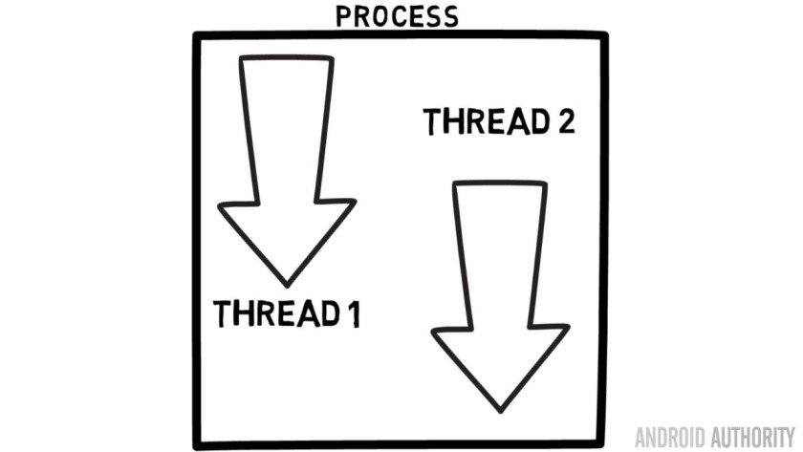

All components that run in the same process are instantiated in the UI thread, and system calls to each component are dispatched from that thread.  If everything is happening in the UI thread, performing long operations such as network access or database queries will block the whole UI. When the thread is blocked, no events can be dispatched, including drawing events. From the user's perspective, the application appears to hang.

** All manipulation to your user interface should be done from the UI thread

#### Worker Thread:

Background processes should be done in a separate threads. UI cannot be updated from any thread other than the UI thread or the main thread. To communicate with the UI we can use:

* Activity.runOnUiThread(Runnable)
* View.post(Runnable)
* View.postDelayed(Runnable,long)

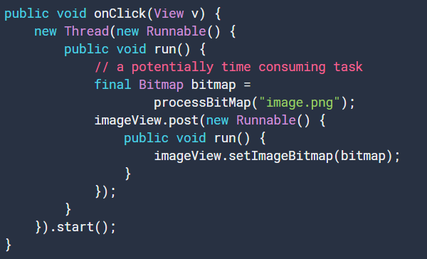

** we can use **Handler** and **AsyncTask** for these type of work

#### Thread-safe methods:

The methods can be called from more than one thread so they must be written to be thread-safe

** Confused

#### Interprocess communication:

A method is called by an activity or other application component, but executed remotely in another process using remote procedure calls(RPCs) with result returned back to the caller.

With this the os understand method call and its data , transmit from local to remote process and address space, then reassemble the call there. Return value in opposite direction.

To perform IPC app must bind to a service using bindService()

06-05-2020

#### The classes for running a thread:

* Basic class
  + Thread
  + Runnable
* Helper classes
  + HandlerThread
  + AsyncTask
  + IntentService
  + ThreadPoolExecutor

1. For running a task once – **Runnable**
2. For running a task repeatedly on different sets of data but one execution running at a time -  **IntentService**
3. For running multiple tasks at the same time – **ThreadPoolExecutor**

#### AsyncTask class:

* Simple and quickly move work from the main thread onto worker thread
* All AsyncTask objects is pushed into a single thread
* Execute in serial fashion
* Long work packet can block the queue
* Use AsyncTask to handle shorter work (<5ms)
* To get reference to the UI object use WeakReference

#### HandlerThread Class:

* Is good for longer running thread
* It mainly grabs from a queue ( Looper)

#### ThreadPoolExecuter class:

* Work good for parallel, distributed tasks.
* Eg. Calculating filter for each 8*8 block of an megapixel image
* AsyncTask is single threaded so not good for this work
* HandlerThread would require managing the load balance between threads
* This helper class create a group of threads, sets their priorities, manages how work is distributed
* The min and max no. of threads can be set in the constructor

#### IntentService – later

#### How many threads should be created?

* Testing with Systrace and trial and error to discover the min no. of threads
* Each thread costs a min of 64k of memory

## Thread Deep Dive:

Link: <https://www.youtube.com/watch?v=TN-CGfzvBhc&t=1100s>

<https://medium.com/better-programming/a-detailed-story-about-handler-thread-looper-message-queue-ac2cd9be0d78>

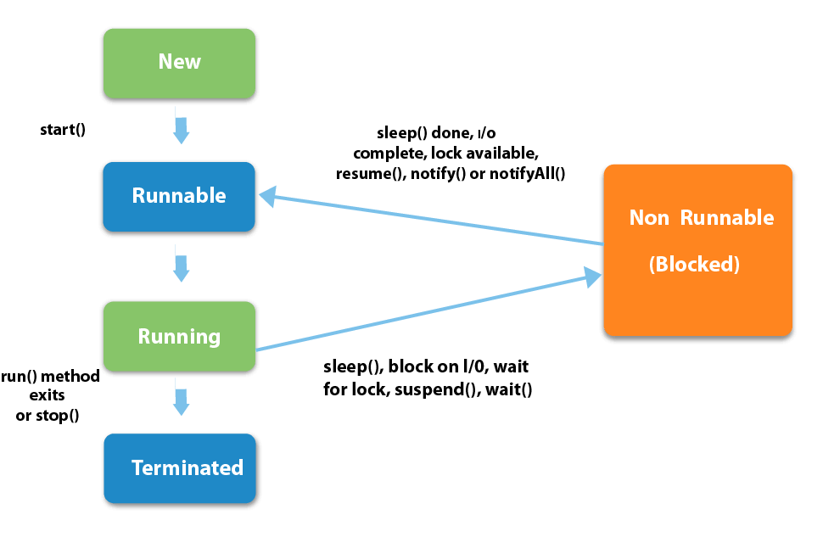

**Message, MessageQueue,Looper**

* List of tasks to be executed in a certain thread. Android maintains a MessageQueue on the main thread
* MessageQueue class holds the list of messages to be dispatched by the looper
* Messages are not added directly to a MessageQueue, but rather through handler objects associated with the looper.
* The looper is responsible for keeping the thread alive
* Looper loops through a message queue and sends messages to corresponding threads to process.
* There will be only one unique looper per thread
* There can be any number of handlers for one single thread.

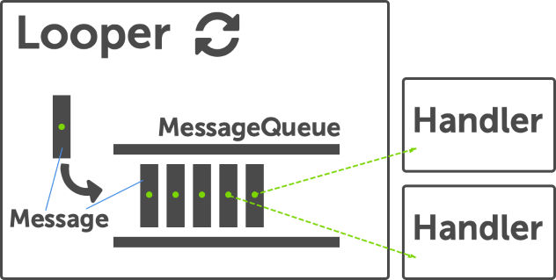

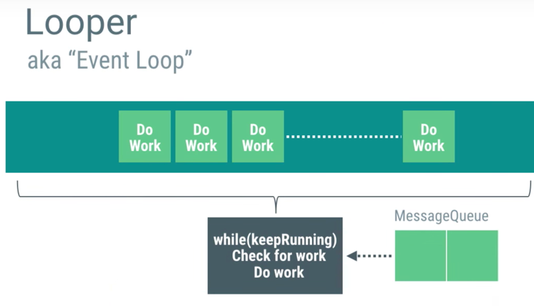

## Process (theory):

* Instead of one task thread can do several task sequentially
* This sequence is called MessageQueue , It is a list of messages instead of runnable , though the runnable can be send in the message by msg.callback or handler.post
* This MessageQueue is loop through using a infinite looper until there is an exit message. This keeps the thread alive (like main thread)
* Every thread will have only one MessageQueue and one Looper
* The Messages in the message queue is handled by the handler. so that messages ( or runnables) can be push into the queue not only sequentially but also with a time constraint ( delay , at a certain time ) .
* The thread is always running until exit message with the help of the looper . and tasks are executed from the message queue. And task are assigned with the handler

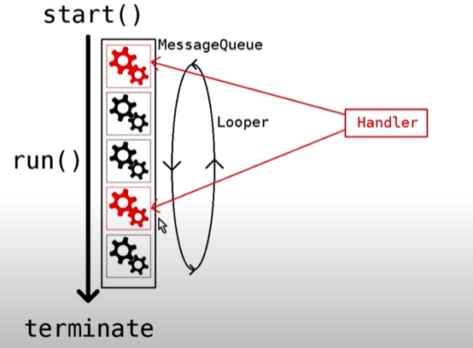

# AsyncTask:

#### Links: <https://codelabs.developers.google.com/codelabs/android-training-create-asynctask/index.html?index=..%2F..android-training#0>

#### <https://www.youtube.com/playlist?list=PLrnPJCHvNZuD52mtV8NvazNYIyIVPVZRa&pbjreload=10>

* An abstract class
* AsyncTasks should ideally be used for short operations.
* Run on background thread but publish it’s result on the UI thread.
* Defined by 3 generic types – Params, Progress, Result
* Four steps – onPreExecute, doInBackground, onProgressUpdate and onPostExecute

The three generic type is for:

* Params – the type of data sent for execution
* Progress – the type of the progress units
* Result – the type of the result of the background task.

The four step can be described as:

* onPreExecute – invoked on the Ui thread before task is executed, for setup task like showing progress bar
* doInBackground – invoked on Background thread. Perform background computation. And return the result.
* onProgressUpdate - This is invoked on the UI thread and used for updating progress in the UI
* onPostExecute - Again on the UI thread, this is used for updating the results to the UI once the AsyncTask has finished loading.

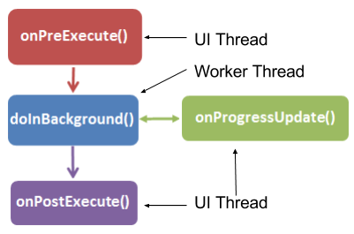

## Procedure:

* create a subclass that extends AsyncTask and set the params
* create member variables for the views on the top class using WeakReference
  + if we directly pass view through constructor then the activity cannot ever be garbage collected and this leaks memory even if the activity destroyed.
* Implement the doInBackground task and return the result to change in UI thread
* Implement onPostExecute to make changes in UI with the result.

07-05-2020

# Loading Large Bitmaps Efficiently

To avoid java.lang.OutOfMemory exceptions, check the dimensions of a bitmap before decoding it.

BitmpFactory class provides several decoding method that allocate memory for the constructed bitmap.

Use BitmapFactory.Options class and set inJustDecodeBounds to true so that it will return null for the bitmap object but we can get width ,height and mimeType .

So, now we can decide whether the full image is needed to load or a subsampled version, consider the following

* Estimate memory usage for the full image
* Fix the amount of memory to load the image according to application requirement
* Dimensions of the target UI component
* Screen size and density

 it’s not worth loading a 1024x768 pixel image into memory if it will eventually be displayed in a 128x96 pixel thumbnail in an [ImageView](https://developer.android.com/reference/android/widget/ImageView).

17-05-2020

# Google ads

## Initialize the google ad mob

* **Add implementation 'com.google.android.gms:play-services-ads:19.1.0'**
* **Add <meta-data  
              android:name="com.google.android.gms.ads.APPLICATION_ID"  
              android:value="*ca-app-pub-xxxxxxxxxxxxxxxx~yyyyyyyyyy*"/>**

## Native ads:

app receives a NativeAd object that contains its assets, and the app (rather than the Google Mobile Ads SDK) is then responsible for displaying them.

loading an ad via the SDK and displaying the ad content in your app

#### ***Make all calls to the Mobile Ads SDK on the main thread.

Attempting to load a new ad from the **onAdFailedToLoad()** method is strongly discouraged

performance is closely linked to where the ad is placed and how the ad looks - both features you can control

## Best practices:

Best practice: <https://admob.google.com/home/resources/native-ads-playbook/>

Policies: <https://support.google.com/admob/answer/6329638>

Check list: <https://support.google.com/admob/answer/6240814>

#### for design:

* Align elements and use similar fonts, colors, and styles
* Avoid stretching or cropping advertiser assets
* Always include the Ad badge and Ad Choices icon
* Distinguish your native ad with subtle visual cues like elevation or drop shadows.
* consider a larger-sized layout to make the ad more noticeable
* Always include Install, Shop Now, Get Started, or Learn More to drive engagement.

#### For placement:

* Fit the ad within the app’s content and design flow, but be sure it’s distinguishable
* Your ads shouldn’t get in the way of what users are doing in your app
* Users should see your ad when they’re considering the content on your screen, not when they’re trying to go somewhere else.

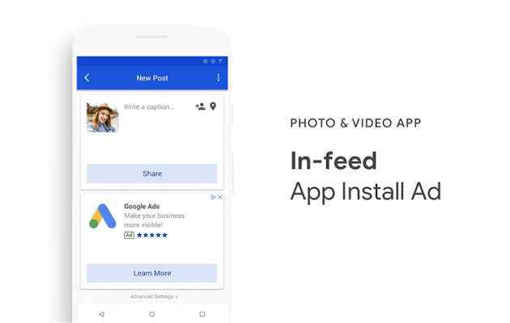

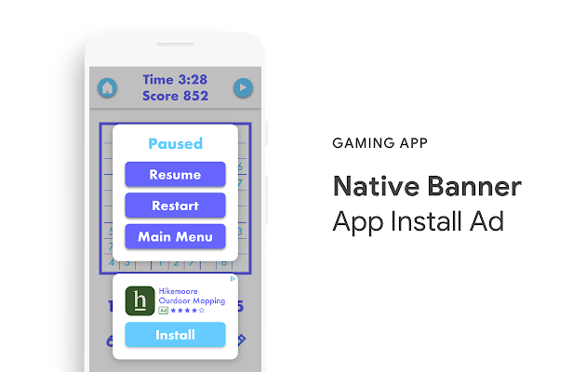

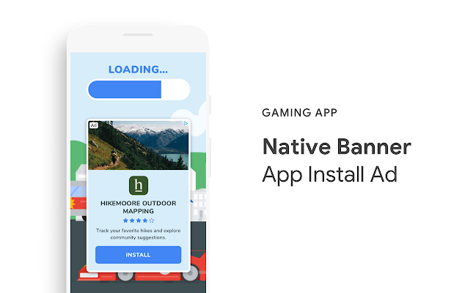

## Policies:

* Native **ads** smaller than **32x32dp (Android) or 32x32pts (iOS)** will not serve.
* **MediaView** must be at least **120x120dp (Android) or 120x120pts (iOS)**
* **Ensure** the **ad assets** are **not outside** of the **native ad view.**
* All native ad **assets must be contained** inside the native ad view.
* **Required elements** include Ad Attribution, AdChoices (or Ads by Google, where applicable) icon, image elements, text elements, and other elements depending on the native ads format.
* The **Ad Attribution and AdChoices** (or Ads by Google, where applicable) icon is must
  + Ad attribution : A badge that says "Ad" (**minimum 15px height/width**)
  + Ad choices or Ads by Google : You can choose to render the AdChoices icon in **any of the four corners** of your ad.
* Image Elements:
  + Publishers are allowed to **crop the image** symmetrically by up to **20% in only one dimension** (height or width)
* Text Elements:
  + **Title text (required)**: Ensure that there is **no truncation** of text up to **25 characters**.
  + **Body text (optional)**: Ensure that there is **no truncation** of text up to **90 characters**
  + **Font size** must be **consistent with other** surrounding elements in the app
* Other Elements:
  + The **app store icon** (image), **price** text, and **star/review** elements **are optional** for **app install ads** and **video app install ads**.
  + The **URL** is **optional** for **content** ads.
  + **Buttons** in both **app install and content ads** required **at least one** of the .**SVG icon** or the **text element**
  + The **background** of the ad must be **not clickable.**
  + **MediaView is required** to render the main **video or image** asset in an ad

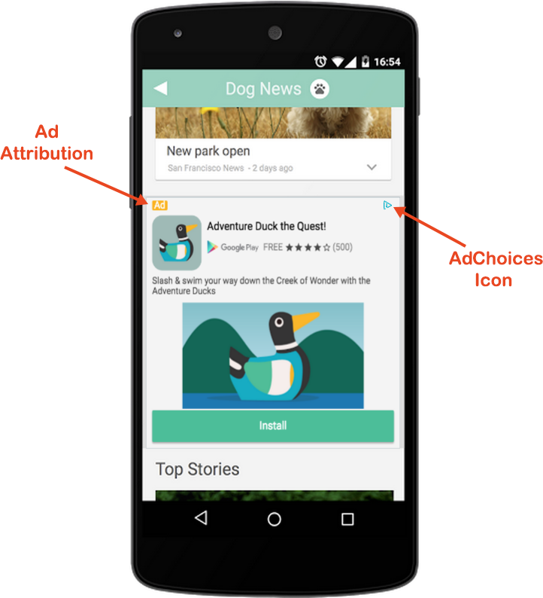 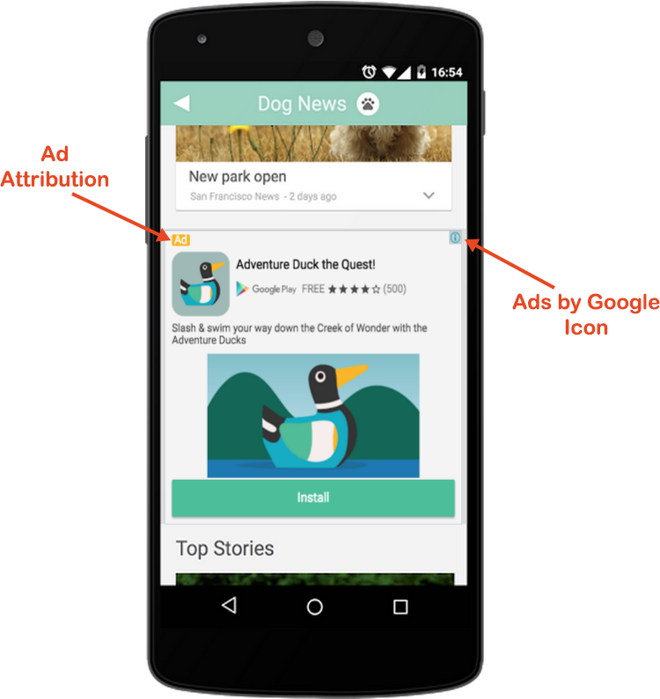

## Checklists:

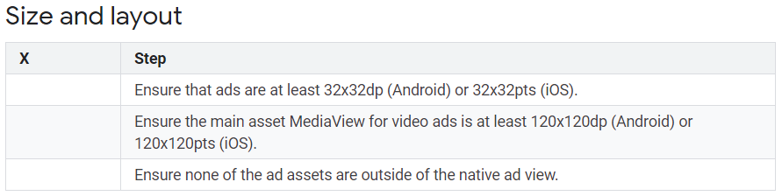 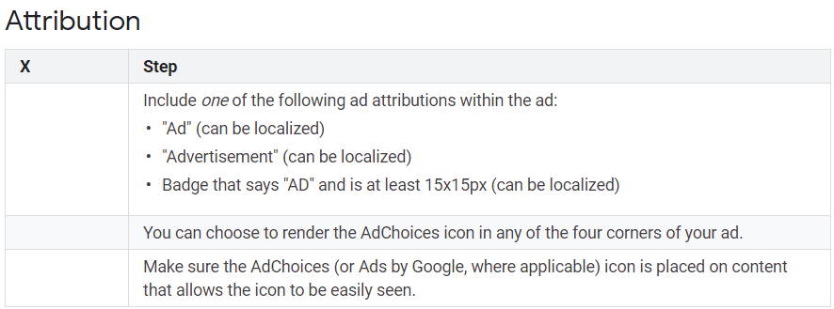 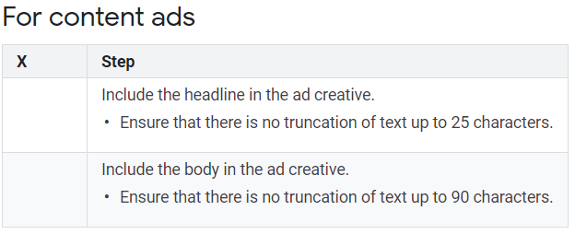

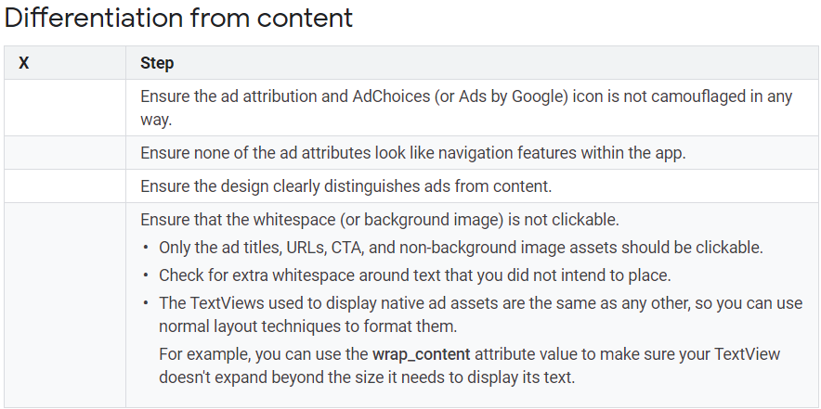

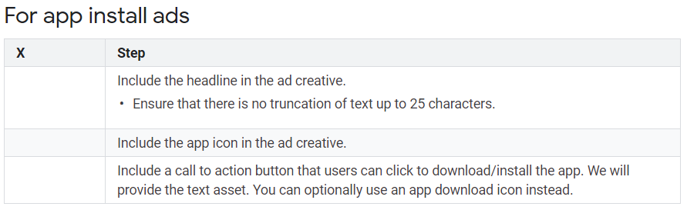

## Some important other policies:

* Phrases such as “click the ads” or similar language are not allowed
* Make sure to prepare fixed space for ads when loading a new screen in your app to avoid accidental click when the ad loads with delay
* Ads should not be placed upon launching the app, potentially leaving the app or after performing a specific action on the screen such as a purchase or download
* There must be a way to exit any screen that contains an ad without having to click on the ad
* a new ad request should not be made sooner than the recommended 60 second rate.

# Implementation:

Interstitial Ads

**Interstitial ads are full-screen ads that cover the interface of their host app. They're typically displayed at natural transition points in the flow of an app, such as between activities or during the pause between levels in a game.**

# Implementation steps:

***Make all calls to the Mobile Ads SDK on the main thread.

* Create an interstitial ad object

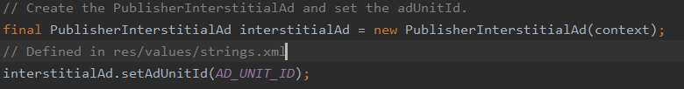

* Always test with test ads

Link: <https://developers.google.com/ad-manager/mobile-ads-sdk/android/test-ads>

* Load an ad



* Show the ad

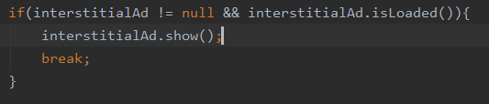

* Ad events

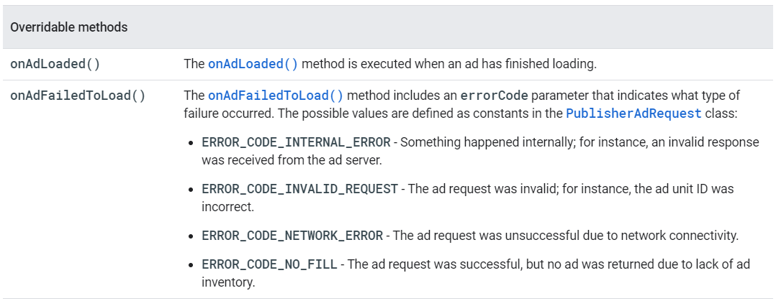

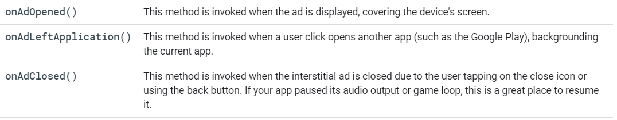

* Using an AdListener to reload

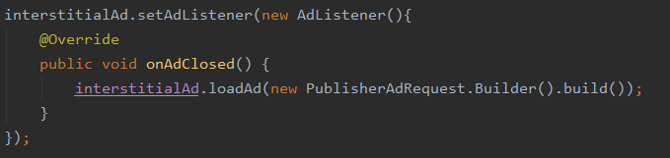

Warning: Attempting to load a new ad from the onAdFailedToLoad() method is strongly discouraged.

## Some best practices and policies:

* Interstitial ads work best in apps with natural transition points.
  + The conclusion of a task within an app, like sharing an image or completing a game level, creates such a point.
* **Remember to pause the action when displaying an interstitial ad.**
  + Pause any audio output being produced by your app.
  + Consider temporarily halting any intense computation tasks (such as a game loop) while the ad is being displayed.
* **Allow for adequate loading time.**
  + make sure the user doesn't have to wait for them to load
  + Loading the ad in advance by calling loadAd() before you intend to call show() can ensure that your app has a fully loaded interstitial ad ready to show()
* **Don't flood the user with ads.**
  + High frequency ad load can also degrade the user experience and lower click through rates.
  + Make sure that users aren't so frequently interrupted that they're no longer able to enjoy the use of your app.
* **Don't use interstitial ads at the very beginning and closing of the app.**
* **Use a timestamp to show the app rather than showing in constant frequency.**
* **Don’t use interstitial ads after a new activity loads, you must show it before the new activity loads.**

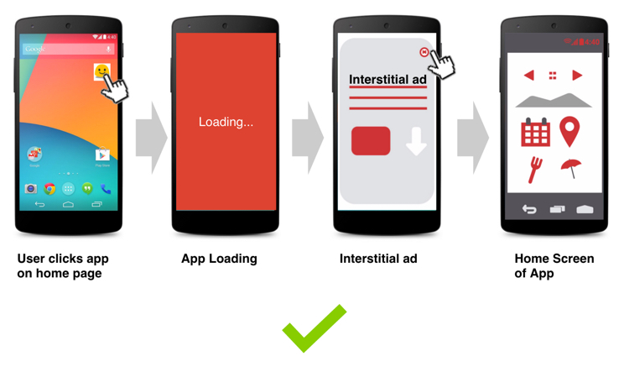

Rewarded ads

Rewarded ads are ads that users have the option of interacting with [in exchange for in-app rewards](https://support.google.com/admob/answer/7313578).

# Implementation steps:

***Make all calls to the Mobile Ads SDK on the main thread.

* Create a rewarded ad object



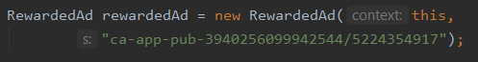

* Always test with test ads
  + Unit_id: ca-app-pub-3940256099942544/5224354917
* Load an ad with a callback

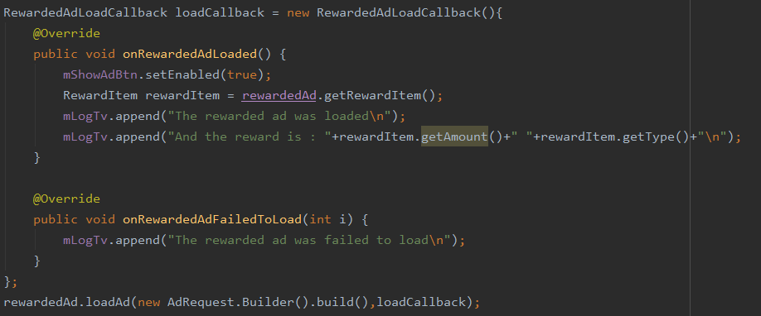

Warning: Attempting to load a new ad from the onRewardedAdFailedToLoad() method is strongly discouraged.

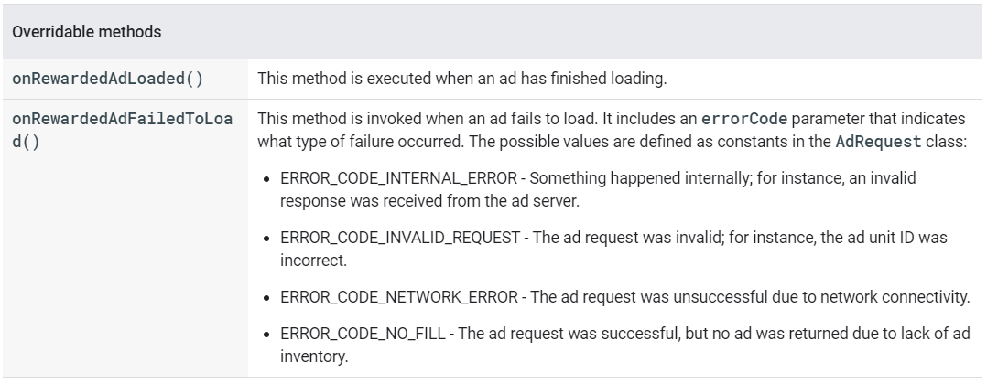

* To get the reward item before showing the ads

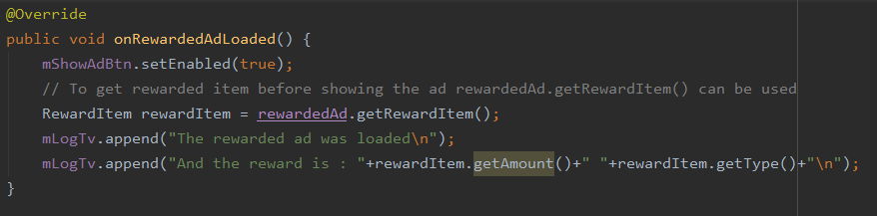

* Show the ad

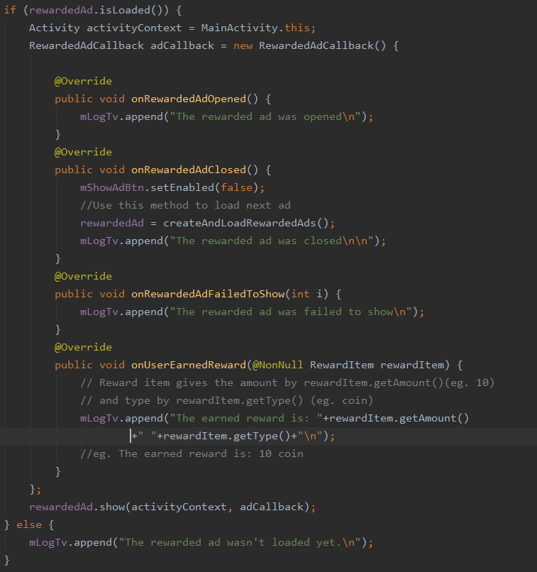

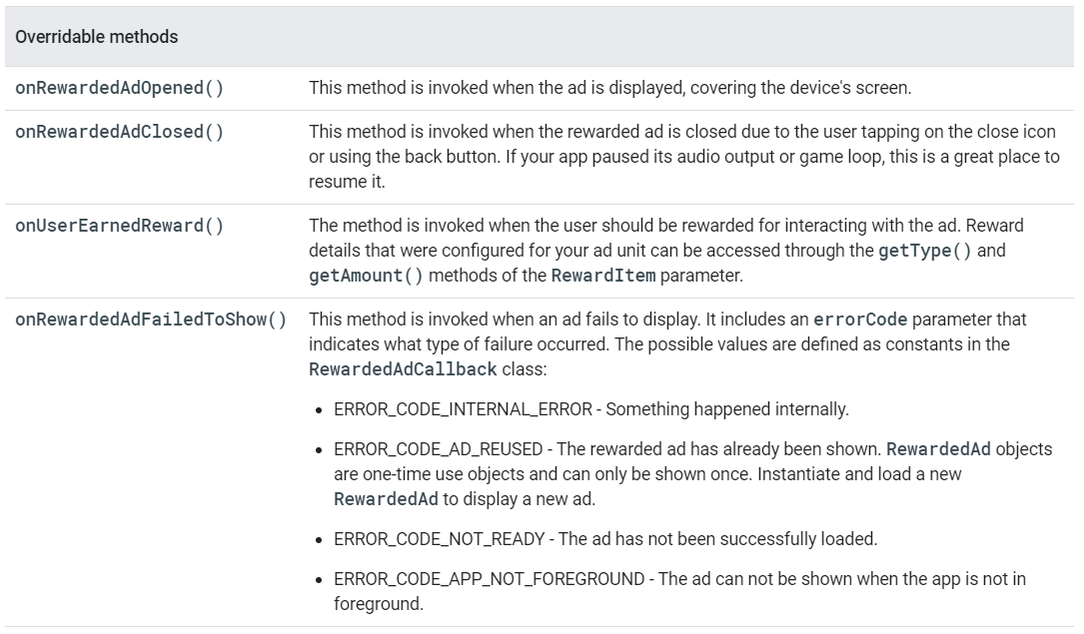

* Loading multiple rewarded ads

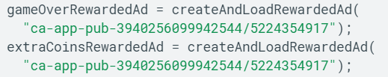

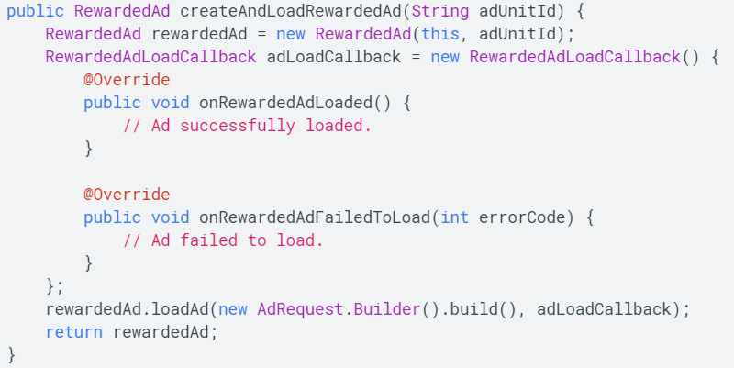

Banner Ads

Banner ads occupy a spot within an app's layout, either at the top or bottom of the device screen. They stay on screen while users are interacting with the app, and can refresh automatically after a certain period of time.

# Implementing Banner Ads:

* Add AdView to the layout

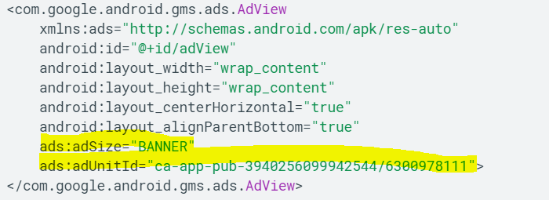

* + adSize: size of the banner .Specify the size of the banner according to various banner size
  + adUnitId: Set this to the unique identifier given to the ad unit in your app where ads are to be displayed. Use test id for testing the
* The table for different banner sizes:

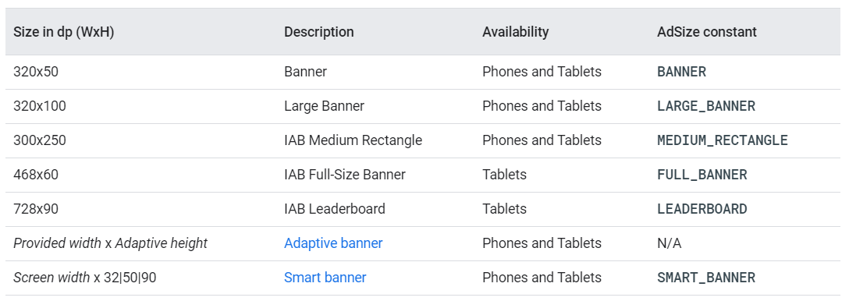

* We can also create AdView programmatically and add to the view hierarchy

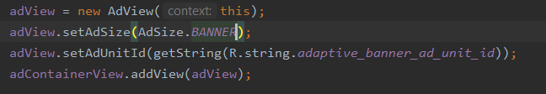

* To define custom banner size use AdSize adSize = new AdSize(300, 50);
* Always test with test ads
  + unitId: ca-app-pub-3940256099942544/6300978111
* Load an ad

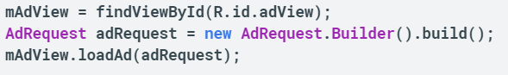

* To further customize the behavior of your ad, you can hook onto a number of events in the ad's lifecycle

